Name:
Name:
Name:
Name:
Hour:

English 9
Mini Research Activity: Night and the Holocaust GROUP WORK, PART A

Survivor Stories
Make sure each group member has written a five-sentence paragraph about the experience of the survivor during the Holocaust. NO COPYING AND PASTING FROM THE ARTICLE! ANSWERS NEED TO BE IN YOUR OWN WORDS!

Group Member Name: | Survivor Name:
 | type your five-sentence paragraph here

Group Member Name: | Survivor Name:
 | type your five-sentence paragraph here

Group Member Name: | Survivor Name:
 | type your five-sentence paragraph here

Group Member Name: | Survivor Name:
 | type your five-sentence paragraph here

Mini Research Activity: Night and the Holocaust GROUP WORK, PART B

Holocaust Background Information
NO COPYING AND PASTING FROM THE INTERNET! ANSWERS NEED TO BE IN YOUR OWN WORDS!

Group 1: What was Kristallnacht?
1. When did Kristallnacht happen and what was it?
type your answer below the question here
2. What was the supposed spark that initiated this violence?
type your answer below the question here
3. What was the role of police on this night?
type your answer below the question here
4. What is “pogrom?”
type your answer below the question here
5. After Kristallnacht, what happened to many Jews?
type your answer below the question here

Possible Sites:
Kristallnacht: A Nationwide Pogrom, November 9-10, 1938
United States Holocaust Memorial Museum Commemorates 70th Anniversary of Kristallnacht
Kristallnacht photos

Group 2: How did Hitler gain power and begin Nazi rule?
1. How and when did Hitler gain power and what was the Third Reich?
type your answer below the question here
2. Who were the SS?
type your answer below the question here
3. What was “Nazi Propaganda,” and how was it used?
type your answer below the question here
4. What is euthanasia?
type your answer below the question here
5. What is “anti-Semitism?”
type your answer below the question here

Possible Sites:
Hitler Comes to Power
Nazi Propaganda

Group 3: What was life like in a concentration camp?
1. What are some of the things that happen to the prisoners when they first got to the camps?
type your answer below the question here
2. What was “Selection?”
type your answer below the question here
3. What was the difference between death camps and labor camps?
type your answer below the question here
4. What happened to the personal items people brought them?
type your answer below the question here
5. What were crematoriums and what were gas chambers?
type your answer below the question here

Possible Links:
Concentration Camps, 1933-1939
Forced Labor: An Overview

Group 4: Did anyone try to save the Jews?
1. How did some people try to rescue Jews?
type your answer below the question here
2. What was the “Resistance” movement?
type your answer below the question here
3. How were some children hidden?
type your answer below the question here
4. What happened during uprisings in camps?
type your answer below the question here
5. What happened during uprisings in ghettos?
type your answer below the question here

Possible Sites:
Chiune Sugihara: Visas For Life
Raoul Wallenberg and the Rescue of Jews in Budapest
Rescuers From the Holocaust/Introduction

Group 5: What was life like in the "ghettos"?
1. How was a ghetto formed?
type your answer below the question here
2. What kind of things did they have in a ghetto?
type your answer below the question here
3. What were some of the rules of the ghetto?
type your answer below the question here
4. How did the Nazis keep the Jews in the ghetto?
type your answer below the question here
5. What happened after the Jews left the ghettos?
type your answer below the question here

Possible Sites:
Ghettos
Krakow (Cracow)
Life in the Ghettos
Lodz
Theresienstadt
Warsaw

Topic 6: What was the “Final Solution?”
1. What was the “Final Solution?”
type your answer below the question here
2. Who were implementers of the “Final Solution?”
type your answer below the question here
3. How was the “Final Solution” supposed to be carried out?
type your answer below the question here
4. How many Jewish lives were lost as a result of “The Final Solution” and the Holocaust?
type your answer below the question here

Possible Sites:
"Final Solution"
"Final Solution" Overview
The "Final Solution"
Wannsee Conference and the "Final Solution"

How to submit this work to Ms. Graham and your group members through Office 365
- Log on to your school email.
- Click on the “waffle” (see photo below)

- Click on “OneDrive” (see photo below)
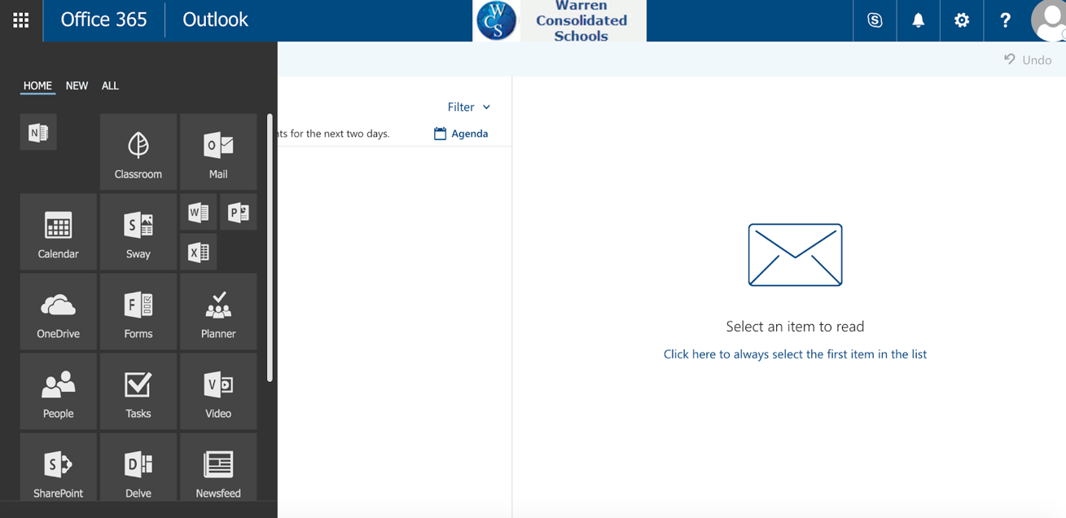
- Click “upload” and in the dropdown menu, click “files” (see photo below)
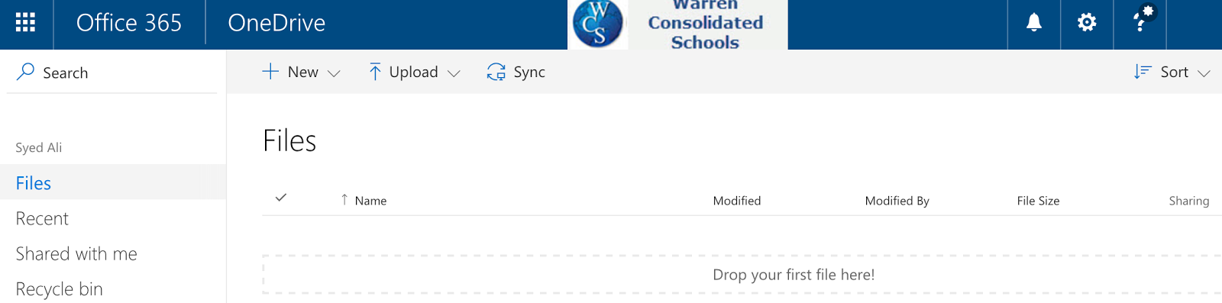

- Find the file “Mini Research Activity Night​ and the Holocaust GROUP WORK PART B”, select the file, then hit “open”
- Now that your file is uploaded, you need to share it with Ms. Graham and your group members. To do this,
- Right click where it says “Only you” with the picture of a lock
- in the dropdown menu choose “Share”
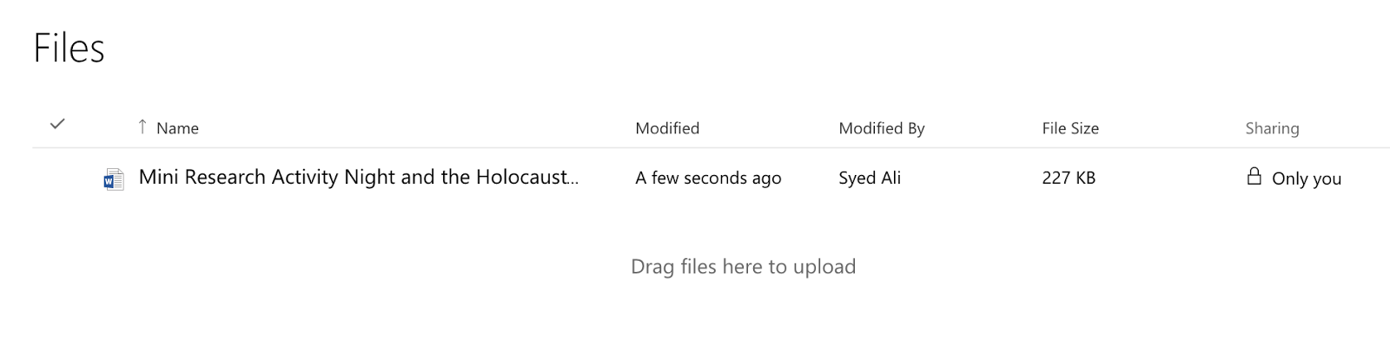

- In the box “Mini Research Activity Night​ and the Holocaust GROUP WORK PART B.docx”, enter kgraham and your group members. DO NOT SUBMIT THIS DOCUMENT UNTIL IT IS FULLY COMPLETE!

How to work on your file ANYWHERE IN THE WORLD through Office 365
- Log on to your school email.
- Click on the “waffle” (see photo below)

- Click on “OneDrive” (see photo below)

- Double click on the file name and your document will open in the web browser you are using (Chrome, Firefox, Internet Explorer, Safari, etc.). So long as your group members are “shared” on the file, they can work in the same document too!

